ACTIVITY, STABILITY AND LIMIT CYCLES BEHAVIOR OF CO OXIDATION OVER Ir/La_{1-x}Sr_{x}MnO₃ PEROVSKITE CATALYSTS

DROSOU C.^{1*}, STRATAKIS A.², FOUNTOULI T.V.¹, NIKOLAOU V.¹, MATSOUKA C.^{3,4}, NALBANDIAN L.⁴, ZASPALIS V.^{3,4}, CHARISIOU N.D.⁵, GOULA M.A. ^{5*}, YENTEKAKIS I.V^{1*}.
¹ Laboratory of Physical Chemistry & Chemical Processes, School of Environmental Engineering, Technical University of Crete, GR-73100 Chania, Greece
² School of Mineral Resources Engineering, Technical University of Crete, GR-73100 Chania, Greece
³ Dept. of Chemical Engineering, Aristotle University of Thessaloniki, GR-54124 Thessaloniki, Greece
⁴ Chemical Processes and Energy Resources Institute, CERTH, GR-57001 Thermi, Thessaloniki, Greece
⁵ Dept. of Chemical Engineering, University of Western Macedonia, GR-50100, Greece
*corresponding authors: I.V. Yentekakis (yyentek@isc.tuc.gr); C. Drosou (EDrosou@isc.tuc.gr); M.A. Goula (mgoula@uowm.gr).

SUMMARY: CO oxidation is one of the most extensively investigated reactions in heterogeneous catalysis, gaining attention, because of its demand in automotive and stationary processes but also its often complicate behavior including steady state multiplicity, limit cycles and rate oscillations. Ir is a relatively cheap noble metal and its consideration in automotive emissions control catalysis (i.e., three-way catalytic converters) and CO processing catalysis (e.g., Fischer-Tropsch synthesis reactions, water gas shift reaction) can be renewed after the lately invented ways for Ir particles stabilization even at stressing high temperature oxidative conditions. Here we report on the CO oxidation behavior over Ir/La_{1-x}Sr_{x}MnO₃ catalysts in a wide range of temperatures (100-450ºC) and at excess oxygen conditions (1% CO, 5% O₂, balance He). La_{1-x}Sr_{x}MnO₃ (x=0, 0.3, 0.5, and 0.7) perovskite supports were prepared by co-precipitation while the addition of Ir (2wt% loading) on the perovskites was employed by wet impregnation. Several pretreatment protocols were carried out in order to investigate in detail the stability of the catalysts and the limit cycle reaction behavior observed with clockwise hysteresis versus temperature. To better understand the structure-activity-stability correlation of the syntesized Ir/La_{1-x}Sr_{x}MnO₃ catalysts, their textural and morphological characteristics were evaluated using various characterization techniques, while extensive catalytic activity and stability experiments were conducted on pre-reduced, pre-oxidized and aged catalysts.
1. INTRODUCTION
Catalytic oxidation of CO has a wide range of applications, among others, the control of automotive emissions and the preferential CO oxidation for hydrocarbons reformate purification towards H₂ production (Yentekakis and Dong, 2020). When CO oxidation is studied as a probe reaction, its simplicity (it has just a single product) enables an in-depth investigation of catalytic behaviour of innovative catalytic materials (Soliman, 2019; Freund et al., 2011).
Perovskites (ABO₃), are characterized by remarkable thermal stability, oxygen ion mobility and crystalline structure and Mn-La-based perovskites are the most popular systems as catalysts and/or electrocatalysts in fuel cells. The partial substitution of La³⁺ by Sr²⁺ in the La_{1-x}Sr_{x}MnO₃ perovskite structure can enhance the redox properties of the material by increasing the oxygen vacancies and the oxidation state of the B cation, introducing significant changes in their catalytic performance and stability (Peña and Fierro, 2001; Royer et al., 2014). Perovskites show good catalytic activity in oxidation reactions such as CO oxidation, but typically at elevated temperatures. However, taking advantage of their properties, perovskites could be used as “active” supports in supported noble metal catalysts, contributing to the global activity and stability of the material, therefore enabling the reduction of the loading of the expensive noble metal in catalyst formulations (Yentekakis and Konsolakis, 2016).
Iridium is a relatively inexpensive noble metal compared to other metals in its group that shows exceptional properties in CO and hydrocarbon oxidation reactions, as well as in NO_{x} reduction reactions. The main inhibiting factor for the use of Ir as a catalyst in such applications is its high propensity to agglomerate under high temperature oxidizing conditions (Yentekakis et al., 2015; Yentekakis et al., 2016). However, a method of stabilizing prone to sintering nanoparticles at high temperature oxidative conditions has been recently proposed (Yentekakis et al., 2016; Yentekakis et al., 2018; Goula et al., 2019). The method is based on the use of supports with high oxygen storage capacity / lability values ​​as substrates for the dispersion of nanoparticles, which endow their surfaces with an electric double layer [O^{δ-}, δ⁺] that is resistant to particle migration and coalescence (PMC) by the electrostatic repulsive forces developed (Yentekakis et al., 2016; Yentekakis et al., 2018; Goula et al., 2019). At the same time, surface oxygen vacancies, usually abundant on the surface of such supports, act as trapping centers that inhibit the growth of catalyst nanoparticles through the Ostwald ripening mechanism (Goula et al., 2019). Perovskites as catalyst particles supports are possible candidates to induce such particles anti-sintering characteristics. On the other had they considerable activity in CO oxidation reaction.
In the present study, four perovskites of the general formula La_{1-x}Sr_{x}MnO₃ (x=0, 0.3, 0.5 and 0.7) were prepared by co-precipitation and were used as supports for the dispersion of Ir nanoparticles. Τhe textural and structural properties of Ir/La_{1-x}Sr_{x}MnO₃ catalysts were evaluated by various techniques, such as X-ray diffraction (XRD), BET-BJH N₂ adsorption-desorption, temperature-programmed reduction by H₂ (H₂-TPR), and isothermal H₂ chemisorption (H₂-Chem) in order to better understand structure-activity-stability correlations. The catalytic activity of the materials was evaluated comparatively on both pre-reduced and pre-oxidized catalysts and on catalysts which have experienced several sequential aging steps at high temperature oxidative environments.
2. EXPERIMENTAL
2.1. Ir/LSM catalysts synthesis
Perovskite supports with the general chemical formula La_{1-x}Sr_{x}MnO₃ (x=0, 0.3, 0.5 and 0.7) were synthesized by co-precipitation. La(NO₃)₃∙6H₂O (Sigma Aldrich), Sr(NO₃)₂ (Sigma Aldrich) and Mn(NO₃)₂∙4H₂O (Merck) nitrate salts were used as precursors, while NaOH (Sigma Aldrich) was used as a precipitant agent. Initially, stoichiometric amounts of nitrate salts were dissolved in double deionized water under continuous magnetic stirring and then precipitated with an aqueous NaOH solution (2M). Then, the solution was heated at 90° C to precipitate, under magnetic stirring. The resulting precipitate was filtered off, dried in air and pulverized. Finally, it was calcinated at 1000° C to obtain the desired perovskite phase (Matsouka et al., 2018; Haron et al., 2014). The synthesized perovskites with the general formula La_{1-x}Sr_{x}MnO₃ will hereinafter be referred to as LSMxx, with xx indicating the % molar Sr constitution in respect to the total La-Sr moles in the perovskite chemical formula (Table 1).
Iridium was incoprorated on the LSM supports using the conventional wet impregnation method. Approprtiate amounts of the as prepared LSM perovskites were impregnated by a IrCl₃ aqueous solution of 2mg Ir/mL (prepared by dissolution of IrCl₃·xH₂O (99.9%, abcr) in de-ionized water) in order to obtain an Ir loading of 2 wt%. The slurries were under continuous stirring on a hot plate at 75ºC until drying. The resulting materials were further dried at 110 ºC overnight and then moved in a gas flowing system for a 3 h reduction at 400 ºC under 25 % H₂/He flow to achieve the effective removal of residual chlorine resulted from the decomposition of the IrCl₃ precursor and to avoid the formation of large Ir crystallites (Yentekakis et al., 2016). Under this preparation procedure four Ir/LSMxx catalysts were prepared (Table 1).

Table 1. Textural, morphological and reducibility characteristics of the La_{1-x}Sr_{x}MnO₃ perovskite supports and the counterpart 2wt%Ir/La_{1-x}Sr_{x}MnO₃ catalysts.
Sample code | Chemical Formula | S_{BET} (m²/g) | Average pore diameter (nm) | Total OSC  (μmol O₂/g) | Mean Ir particle size (nm)* | Ir Dispersion (%)
LSM00 | LaMnO₃ | 12.0 | 10.9 | 671 | - | -
LSM30 | La_{0.7}Sr_{0.3}MnO₃ | 10.4 | 9.84 | 766 | - | -
LSM50 | La_{0.5}Sr_{0.5}MnO₃ | 6.8 | 8.91 | 886 | - | -
LSM70 | La_{0.3}Sr_{0.7}MnO₃ | 11.3 | 8.79 | 1219 | - | -
Ir-LSM00 | 2wt%Ir/LaMnO₃ | 9.7 | 11.9 | 502 | 1.1 | 63
Ir-LSM30 | 2wt%Ir/La_{0.7}Sr_{0.3}MnO₃ | 10.5 | 9.96 | 981 | 1.1 | 62
Ir-LSM50 | 2wt%Ir/La_{0.5}Sr_{0.5}MnO₃ | 6.2 | 8.11 | 1203 | 1.0 | 73
Ir-LSM70 | 2wt%Ir/La_{0.3}Sr_{0.7}MnO₃ | 11.0 | 13.7 | 1348 | 1.2 | 61
*Estimated by means of H₂-uptake values obtained in H₂-chemisorption experiments and assuming one-to-one H-to-Ir correlation (i.e. dissociative H₂ chemisorption).
2.2. Activity and stability experiments
Catalytic performance and thermal stability experiments were carried out in a quartz tubular fixed-bed reactor, with a 3.0 mm inner diameter. Catalyst loading was 20 mg and the total gas flow rate was 160 mL/min (wGHSV=480,000 mL/g∙h). CO oxidation was studied under O₂ excess conditions, using a gas feed v/v% composition of 1% CO, 5% O₂, He balance at 1 bar. All catalysts were studied after exposing them at two different pre-treatment conditions: (a) pre-reduced catalysts in a 25% H₂/He flow (50 mL/min) at 400ºC for 1 h, and (b) pre-oxidized catalysts in a 20% O₂/He flow (50 mL/min) at 400ºC for 1h. Typical catalytic experiments were conducted in the form of light-off diagrams, i.e. CO conversion vs temperature in the range of 50-400º C.
The Ir/LSM catalysts vulnerability to sintering and the concomitant effects on CO oxidation activity were studied by applying sequential thermal aging steps, where the samples were subjected to the same aging protocol as follows: (i) an in situ oxidation for 5 h at 600°C, followed by (ii) a in situ oxidation for 5 h at 750°C, using 20% O₂/He flow (50 mL/min). After each aging step, the catalysts were reduced rapidly (0.5 h at 25% H₂/He flow of 50 mL/min) at the same temperature to test their activity at a constant temperature of 350ºC, and reaction conditions similar to those used in the other kinetic experiments (i.e. 1% CO, 5 % O₂, balance He at 1 bar).
The continious flow apparatus used herein is equiped with on-line gas chromatography (Shimadzu 14 B, TC detector, He carrier gas) for the analysis of reactants and products. CO conversion efficiency as a function of temperature (light-off diagrams) was investigated in the temperature range of 100-450ºC.

2.3. Characterization techniques
The textural characteristics of the LSM supports and counterpart Ir/LSM catalysts were determined by the N₂ adsorption-desorption isotherms carried out at -196ºC on in situ pre-degassed samples at 350ºC for 12 h, using a Nova 2200e Quantochrome. Samples were degassed at 350ºC, for 12 h. The surface areas (S_{BET}) were obtained according to Brunauer-Emmett-Teller (BET) method, total pore volume was calculated based on nitrogen volume at the highest relative pressure and the average pore size diameter was determined by the Barrett-Joyner-Halenda (BJH) model.
Powder X-ray diffraction (XRD) analysis was performed on a BrukerAXS D8 Advance diffractometer at 35 kV and 35 mA with Cu Kα radiation and LynxEye detector with Ni-filter. The measurements were carried out in the 2θ angle range of 4–70 degrees with a scanning speed of 0.5 degrees per minute. Samples were calcinated in air at 400º C for 1 h, before XRD measurements. Crystallography Open Database (COD) was used for the identification of the crystal structures. The quantification of the phases in the samples was performed with the Rietveld method using BrukerAXS Topas software. The average particle size of different phases was calculated with the Scherrer equation, based on their most intense diffraction peaks.
Hydrogen temperature programmed reduction (H₂-TPR) measurements were performed by a Quantachrome/ChemBet Pulsar TPR/TPD chemisorption analyzer equipped with an Omnistar/Pfeiffer Vacuum mass spectrometer to record the H₂-consumption profiles and to evaluate the oxygen storage capacities (OSC) of the materials by using the values of total amount of H₂ consumed. Before data acquisition, samples were oxidized in situ with 20% O₂/He at 450 °C for 2 h followed by cooling to 140ºC. At this temperature the system was purged by He flow for 10 min and then cooled under the same flow to room temperature. Then the TPR measurements carried out with a flow of 20 cm³/min of 5% H₂/He and a temperature ramp rate of at 10 °C/min up to 800 °C. Τhe method of calculating total OSC values from H₂ consumption profiles can be found elsewhere (Goula et al., 2019).
Isothermal H₂ chemisorption measurements (at 25ºC) were conducted with the same instrumentation used in H₂-TPR experiments. To this end, ~150 mg of catalyst was loaded into a quartz U-tube connected to the analyzer and pretreated before the H₂-uptake measurement, as follows: Reduction at 550 °C for 1 h with a flux of 15 mL/min 5% H₂/He, gas phase purging at the same temperature for 0.5 h by a 15 mL/min N₂ flux and finally cooling 25 °C under N₂ flow. Pulses of pure H₂ (280 μL) were then injected until saturation, providing the total uptake of chemisorbed H₂. These values were used to estimate the number of active Ir sites assuming one-to-one correlation of adsorbed H atoms with metal sites (i.e. H-Ir), and hence Ir dispersion and mean crystallite size (Goula et al., 2019).
3. RESULTS AND DISCUSSION
3.1. Materials characterization results
3.1.1 Textural, structural and morphological characteristics
The textural characteristics of the prepared LSM perovskites and Ir-LSM catalysts are summarized in Table 1. The total surface area (S_{BET}) of the perovskite supports is ranging from 6.8 to 12.0 m²/g while a slight decrease in S_{BET} is the result of the addition of iridium.
The PXRD data of LSM supports and counterpart Ir/LSM catalysts are shown in Fig. 1. For the sake of comparison all samples were pre-oxidized before PXRD experiments. The diffraction patterns shown in Fig. 1 confirm the formation of the LSM perovskite structure, with the main reflection at 2θ between 32.4 and 33.1, since the increase of Sr content results in the shift of the peaks at higher 2θ angles; a peak splitting is also observed (Fig. 1b) which tends to decrease as the substitution of La by Sr increases. Finally, in addition to the perovskite structure, the presence of other crystalline phases such as La and Mn oxides are also apparent. The results are in agreement with literature (Galvez et al., 2015). Due to its high dispersion (low particle size) IrO₂ was not detected by PXRD.
LSM supports and corresponding Ir/LSM catalysts offer high values of oxygen storage capacity in the range of ca. 500 to 1350 μmol O₂/g, which increase gradually as La's substitution by Sr increases (Table 1). Total OSC values, as estimated by H₂-TPR experiments and corresponding to the total available unstable oxygen species up to 750°C, are originating from the redox reactions Mn⁴⁺/M³⁺ (usually occurring at T <500°C), Mn³⁺/ Mn²⁺ (T> 500ºC), and Ir⁴⁺/Ir⁰ (if present, at T <~ 300ºC). Regarding Ir particle sizes and dispersions, all Ir/LSM catalysts prepared herein show very similar values, in the order of 1.0-1.2 nm and 61-73%, respectively (Table 1), as estimated by the H₂-chem. results.
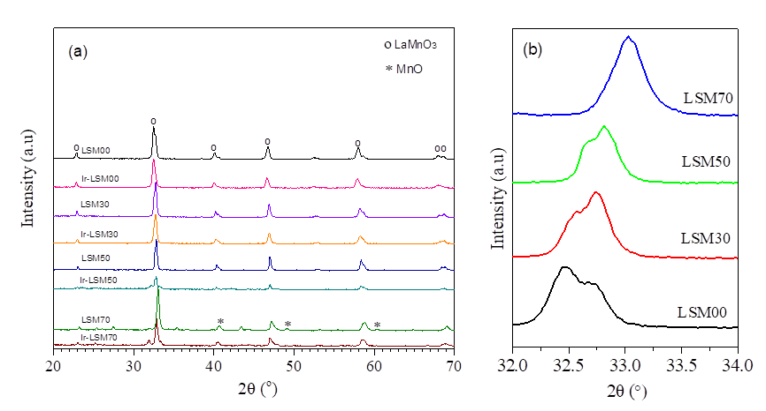
Figure 1. X-ray diffractions patterns of LSM perovskite supports and Ir/LSM catalysts at 20º < 2θ < 70º (a). Enlarged XRD patterns at 32º < 2θ < 34º for LSM perovskites (b).

3.2 Catalytic evaluation results
3.2.1 Catalytic performance of pre-reduced and pre-oxidized samples.
Initially, the catalytic performance of all samples (LSM supports and Ir/LSM catalysts) and in two pre-treatment stages was comparatively evaluated in light-off diagrams (Fig. 2). Specifically, Fig. 2a depicts light-off profiles of pre-reduced samples, while Fig. 2b of pre-oxidized ones. Both Ir-free LSM perovskite supports and corresponding Ir/LSM catalysts, independently of their preconditioning, show considerable activity in CO oxidation. However in both cases, Ir/LSM catalysts have significantly superior behavior versus that of the LSM supports with the light-off profiles of the former to be shifted at ca. 25-85ºC lower temperatures (Fig. 2, Table 2). A superiority in activity of the pre-reduced samples (supports and catalysts) in comparison to the pre-oxidized ones is also obvious, lying typically between ~0 to ~70ºC lower T₅₀ temperatures (Fig. 2, Table 2).
In respect to pre-reduced Ir/LSM catalysts, the activity order is Ir/LSM00 > Ir/LSM30 > Ir/LSM50 > Ir/LSM70, almost similar to that of the LSM supports, i.e. LSM00 > Ir/LSM50 > Ir/LSM30 > Ir/LSM70; this order seems to follow the order of increasing substitution of La by Sr in the perovskite chemical formula.
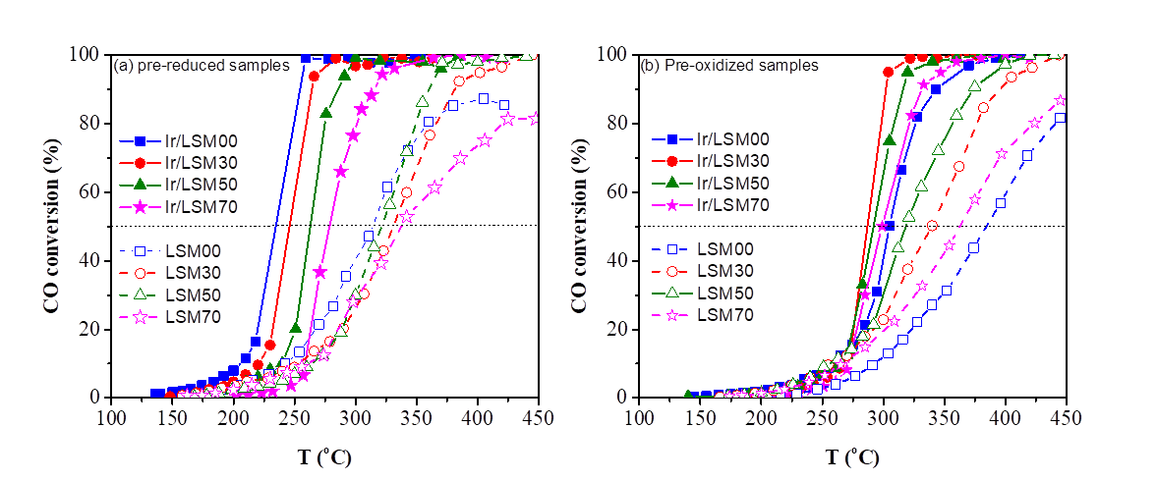
Figure 2. CO conversion versus temperature over LSM supports and counterpart Ir/LSM catalysts with pre-reduced (a) and pre-oxidized (b) samples. Feed conditions: 1.0% CO, 5.0% O_{2,} He balance at 1 bar; F_{T} =160 mL/min, catalyst mass m =20 mg, wGHSV=480,000 mL/g∙h. Open sympols and dashed lines depict LSM perovskite supports, filled symbols and solid lines depict Ir/LSM catalysts (squares: Ir-LSM00; circles: Ir-LSM30, triangles: Ir-LSM50, stars: LSM70).
Table 2. The temperature for 50% CO conversion (T₅₀) on LSM perovskite supports and counterpart Ir/LSM catalysts for pre-reduced and pre-oxidized samples.
Sample code | T₅₀ (ºC)  pre-reduced | T₅₀ (ºC)  pre-oxidized | ΔΤ₅₀ (ºC)  pre-reduced ̶ pre-oxidized | ΔΤ₅₀ (ºC)  Ir/LSM ̶ LSM  (pre-reduced) | ΔΤ₅₀ (ºC)  Ir/LSM ̶ LSM  (pre-oxidized)
LSM00 | 314 | 385 | -71
LSM30 | 331 | 340 | -9
LSM50 | 322 | 318 | +4
LSM70 | 337 | 362 | -25
Ir-LSM00 | 235 | 305 | -70 | -79 | -80
Ir-LSM30 | 246 | 286 | -40 | -85 | -54
Ir-LSM50 | 262 | 292 | -30 | -60 | -26
Ir-LSM70 | 279 | 299 | -20 | -58 | -63

A clear clockwise hysteresis (limit cycle) performance was recorded for all Ir/LSM catalysts upon moving from low to higher temperatures (light-off path) and then returns back (light-out path) (Fig. 3). This behavior, well known in heterogeneous catalysis as hysteresis or limit cycle behavior (Al Soubaihi eta al., 2018) was less apparent on LSM perovskite supports (data not shown) indicating that this phenomenon is mainly related with the Ir active phase. As can be seen in Fig. 3, the light-off path of the limit cycle approaches the independently taken light-off profile of the pre-reduced catalyst, while the light-out path approaches the independently acquired light-off profile of pre-oxidized catalysts (Fig. 2). This corroborates that the limit cycle behavior is most probably related with the Iridium oxidation state of the catalyst; starting the light-off pathway with a pre-reduced catalyst the metallic phase of Ir⁰ (most active in CO oxidation) leads to high CO conversion performance. However, when approaching 100% CO conversion at elevated temperatures the catalyst is faced with net oxidizing conditions due to the remaining excess oxygen which causes the oxidation of iridium particles. Thus returning back to low temperatures (light-out pathway) the catalyst approaches the lower catalytic efficiency of IrO₂ (i.e., that of the pre-oxidized catalyst). Such limit cycles related to the oxidation state of the catalyst often leads to rate oscillations (Yentekakis et al., 1988; Yentekakis and Vayenas, 1988). The GC instrumentation available in our apparatus did not allow us to record such a possible behavior. Work in this direction is in our future plans after upgrading our analysis system with a continuous CO analyzer. Interestingly, the hysteresis decreases in amplitude as the percentage of La replacement by Sr increases.
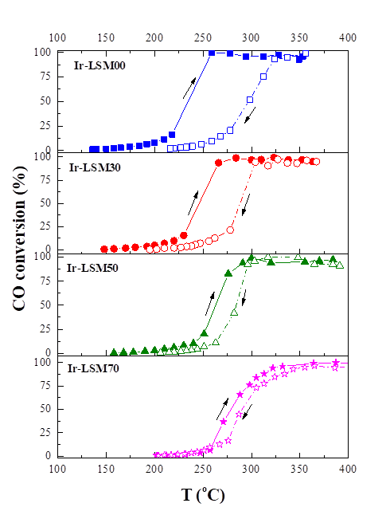
Figure 3. CO conversion light-off and light-out profiles over pre-reduced Ir-LSM catalysts. Narrows show the direction of data acquisition. Experimental conditions: 1.0% CO, 5.0% O₂, He balance at 1 bar; F_{T} =160 mL/min, catalyst mass m=20 mg, wGHSV=480 000 mL/g∙h.
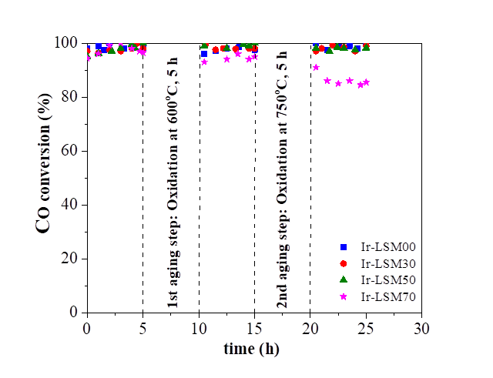
Figure 4. CO conversion efficiency of Ir/LSM catalysts tested after each of two in-situ sequential thermal aging steps at oxidative conditions (20%O₂/He flux of 50 mL/min). 1st step: 5 h at 600ºC; 2nd step: 5 additional hours at 750ºC.
The activity of the Ir/LSM catalysts after exposure to sequential high temperature oxidative aging steps was also assessed (Fig. 4). The great robustness of all Ir/LSM catalysts is clear, despite the fact that IrO₂ is highly prone to agglomeration at such conditions; a slight deactivation was observed only on the sample with the high Sr content (Ir/LSM70). These results indicate that support-induced anti-sinter mechanisms are at work in the present materials due to the high OSC values of the LSM supports, in agreement with the sintering resistance method and model recently reported in series of papers by Yentekakis and co-workers (Yentekakis et al., 2015; Yentekakis et al. 2016; Yentekakis et al., 2018; Goula et al., 2019). In brief the method and the explanation model is based on the fact that supports with high oxygen storage capacity values (and abundant surface oxygen vacancies) spontaneously endow (via thermal diffusion) catalyst particle surfaces with an O^{δ-} species layer that resists particle migration and coalescence (PMC) through the electrostatic repulsive forces developed. At the same time, surface oxygen vacancies of the support act as trapping centers, inhibiting catalyst nanoparticles growth via the Ostwald ripening mechanism (Goula et al., 2019). Thus, the perovskite supports used herein for Ir nanoparticles dispersion satisfy these criteria resulting to very robust Ir-based catalysts, minimizing the propensity of Ir to agglomerate in net oxidizing environments.
4. CONCLUSIONS
In this work, LSM (La_{1-x}Sr_{x}MnO₃, x=0, 0.3, 0.5, and 0.7) perovskite supports and Ir/LSM counterpart catalysts were comparatively studied for their activity and stability after high temperature thermal aging at oxidizing conditions for the CO oxidation reaction. Both LSM supports and Ir/LSM materials are active to CO oxidation, notably in the interest for automotive emissions control catalysis temperature range of ca. 200-450ºC. However, Ir/LSM were significantly more active than LSM alone and in particular in their pre-reduced state, indicating that Ir⁰ phase outweighs IrO₂ in CO oxidation reaction. Increasing the substitution of La by Sr in the perovskite support chemical formula causes a decrease in CO conversion efficiency of the catalysts, which followed the order Ir/LaMnO₃ > Ir/ La_{0.7}Sr_{0.3}MnO₃ > Ir/ La_{0.5}Sr_{0.5}MnO₃ > Ir/ La_{0.3}Sr_{0.7}MnO₃ on pre-reduced samples. Starting with pre-reduced Ir/LSM catalysts, clockwise hysteresis phenomena were valid in light-off light-out experiments, with their temperature altitude to be depressed as the La substitution by Sr increases. The high OSC of the LSM supports endowed Ir nanoparticles with exceptional anti-sinter properties, so as CO oxidation activity of the Ir/LSM catalysts was remained absolutely stable even after exposure to extreme thermal aging conditions at oxidizing environment. Ir/LSM catalysts seem promising in emissions control systems at excess oxygen conditions, e.g., lean-burn and diesel exhaust gases and fossil fuel combustion processes.

ACKNOWLWDGEMENTS
Financial support by the Greek-Chinese bilateral research and innovation cooperation, 2018-2021 program (Project No: T7ΔΚI-00356) is gratefully acknowledged.

REFERENCES
Al Soubaihi, R.M., Saoud, K.M., Dutta, J. 2018. Critical review of low-temperature CO oxidation and Hysteresis phenomenon on heterogeneous catalysts. Catalysts 8, 660.
Freund, H.-J., Meijer, G., Scheffler, M., Schlögl, R., Wolf, M., 2011. CO oxidation as a Prototypical Reaction for Heterogeneous Processes. Angew. Chem. Int. Ed. 50, 10064-10094.
Gálvez, M.E., Jacot, R., Scheffe, J., Cooper, T., Patzke, G., Steinfeld, A., 2015. Physico-chemical changes in Ca, Sr, and Al-doped La-Mn-O perovskites upon thermochemical splitting of CO₂ via redox cycling. Phys. Chem. Chem. Phys., 17, 6629-6634.
Goula, G., Botzolaki, G., Osatiashtiani, A., Parlett, C.M.A., Kyriakou, G., Lambert, R.M., Yentekakis, I.V., 2019. Oxidative thermal sintering and redispersion of Rh nanoparticles on supports with high oxygen ion lability, Catalysts 9 (2019) 541.
Haron, W., Wisitsoraat, A., Wongnawa, S., 2014. Comparison of nanocrystalline LaMO₃ (M = Co, Al) perovskite oxide prepared by co-precipitation method. Int. J. Chem. Eng. Appl. 5, 123-126.
Matsouka, C., Zaspalis, V., Nalbandian, L., 2018. Perovskites as oxygen carriers in chemical looping reforming process – Preparation of dense perovskite membranes and ionic conductivity measurement. Mater. Today: Proc. 5 27543–27552.
Peña, M.A. & Fierro, J.L.G., 2001. Chemical structures and performance of perovskite oxides. Chem. Rev., 101, 1981-2017.
Royer, S., Duprez, D., Can, F., Courtois, X., Batiot-Dupeyrat, C., Laassiri, S., Alamdari, H., 2014. Perovskites as substitutes of noble metals for heterogeneous catalysis: Dream or reality. Chem. Rev. 114, 10292-10368.
Soliman, N.K., 2019. Factors affecting CO oxidation reaction over nanosized materials: A review. J. Mater Res Technol., 2, 2395-2407.
Takalkar, G., Bhosale, R.R., AlMomani, F., Rashid, S., Qiblawey, H., Saad, M. A. S., Khraisheh, M., Kumar, G., Gupta, R.B., Shende, R. V., 2021. Thermochemical splitting of CO₂ using combustion synthesized lanthanum-strontium-manganese perovskites. Fuel 285, 119154.
Yentekakis, I.V., Neophytides, S., Vayenas C.G., 1988, Solid electrolyte aided study of the mechanism of CO oxidation on polycrystalline platinum. J. Catal. 111, 152-169.
Yentekakis, I.V., Vayenas, C.G., 1988. The effect of electrochemical oxygen pumping on the steady-state and oscillatory behavior of CO oxidation on polycrystalline Pt. J. Catal. 111, 170-188.
Yentekakis, I.V., Goula, G., Panagiotopoulou, P., Katsoni, A., Diamadopoulos, E., Mantzavinos, D., Delimitis, A., 2015. Dry reforming of methane: catalytic performance and stability of Ir catalysts supported on γ-Al₂O₃, Zr_{0.92}Y_{0.08}O_{2−δ} (YSZ) or Ce_{0.9}Gd_{0.1}O_{2−δ} (GDC) supports. Top. Catal. 58, 1228–1241.
Yentekakis, I.V., Goula, G., Panagiotopoulou, P., Kampouri, S., Taylor, M.J., Kyriakou, G., Lambert, R.M., 2016. Stabilization of catalyst particles against sintering on oxide supports with high oxygen ion lability exemplified by Ir-catalysed decomposition of N₂O, Appl. Catal. B- Environ. 192, 357–364.
Yentekakis I.V., Konsolakis M., 2016. Three-way Catalysis (Book Chapter). In Perovskites and Related Mixed Oxides: Concepts and Applications. Wiley-VCH, Vergal GmbH & Co. KGaA: Weinheim, Germany; pp. 559–586.
Yentekakis, I.V., Goula, G., Kampouri, S., Betsi-Argyropoulou, I., Panagiotopoulou, P., Taylor, M.J., Kyriakou, G., Lambert, R.M., 2018. Ir-catalyzed nitrous oxide (N₂O) decomposition: Effect of the Ir particle size and metal-support interactions. Catal. Lett. 148, 341–347.
Yentekakis, I.V., Dong, F., 2020. Grand challenges for catalytic remediation in environmental and energy applications toward a cleaner and sustainable future. Front. Environ. Chem. 1, 5.

